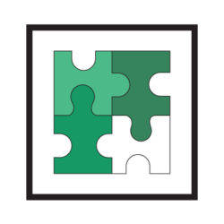
ENVISION OPELIKA
Creating Our Future Together
As we recognize National Day of Giving 2024 this Tuesday, December 3rd, Envision Opelika is excited to announce Opelika Giving Day will be held on Wednesday, May 22, 2024. This 24-hour online fundraising challenge provides an easy and exciting way for individuals, companies, or organizations to support local non-profits, celebrate the joy of helping others, and inspire a new culture of giving within our community.

Applications are now available for Opelika non-profit organizations interested in submitting a project for consideration. Applications and fees are due by 5:00 pm on April 12, 2024. Application submission is not a guarantee that an agency will be selected to participate in Opelika Giving Day. Those selected to participate will be notified by April 26, 2024.

Please complete the attached form or go to www.opelikagivingday.org and click on Project Application.

If you have any questions, please contact info@opelikagivingday.org.

Why should you apply?
- A giving day incorporates your organization into a greater community. Being portrayed as part of a greater community of organizations can establish trust between you and new potential donors.

- A giving day is a great jump-start for your next fundraising campaign. People are more likely to give once they see you have some traction, so take advantage of the excitement of a giving day and leverage it to amass the social proof you need to motivate others to give during a future campaign.

- You can more easily discover, and connect with, like-minded organizations. Partnerships, especially between organizations, are an important part of producing ideas and solutions that address the challenges in your cause sector. Giving days are an amazing way to discover other organizations in your area and find out what they’re working on.

- A giving day is an opportunity to acquire new donors or, at least, reach a new audience. Even if you don’t raise a ton of money on a giving day, by utilizing the day’s attention and momentum you will have gotten in front of at least a few new faces. Anytime you have a chance to showcase your passion for your cause, you’re creating an opportunity to connect with potential donors and build trust with a community of supporters.

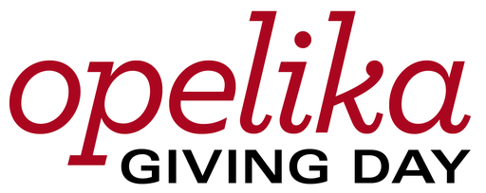

Application
Deadline to submit proposals: April 12, 2024

Project Leader:
Phone:
Email:
Nonprofit Organization Name:
Address:
Web address:
Project Title:
Project Goal amount:
Project Summary:

How does this project benefit the Opelika Community and its citizens?

Please add any additional information you would like to share about your project:

Budget (please itemize costs anticipated):

Project Start & End Date:
Please check the following as confirmation that you agree to the following requirements if selected to participate:
_____ Will submit a project impact report by October 31, 2024 and at the project’s completion to Envision Opelika. If the report is not provided as required, future applications for participation may not be considered.
_____ I understand Envision Opelika will deduct 2% from each project’s total amount raised. This fee helps offset the processing and platform costs.
_____ Will attend an “Opelika Giving Day” recognition event in Summer 2024.
Signature:
__________________________________________

For additional information about OGD and/or the Request for Proposals, please email info@opelikagivingday.org

There will be a $25 application processing fee. Please submit your fee by check or cash to Envision Opelika at 1103 Glenn Street, Opelika, 36801
- or – to pay with credit or debit card, visit the website at https://opelikagivingdays.org/campaigns/application-fee-2024/ or call 334-749-8105.

